**PROJECT WORK REPORT ON**

**House Hunt: Finding your perfect rental homegive**

In

## COMPUTER AND SCIENCE ENGINEERING

## SUBMITTED BY

**Team ID: LTVIP2025TMID52489**

**Team size:4**

**Team Leader: Golla Likhitha**

**Team member: C.Saivarsha**

**Team member:  Harini Ankireddypalli**

**Team member: Bhuma Sharanya**

**RAVINDRA COLLEGE OF ENGINEERING FOR WOMEN**

# DECLARATION

We here by declare that

* The work contained in this report is original and has been done by us under the guidance of our supervisor(s).
* The work has not been submitted to any other institute for obtaining any degree or diploma.
* We have followed the guidelines provided by the institute in preparing there port.
* We have conformed to the norms and guidelines given in the ethical code of conduct of the institute.
* When ever we have used materials (data, theoretical analysis, figures, and text)from other sources, we have given due credit to them by citing in the text of the report and giving their details in the references.

PLACE:

DATE:

**NAME: C.SAIVARSHA**

**Team ID: LTVIP2025TMID** **52489**

**TABLE OF CONTENTS**

**CHAPTER 1**

##### INTRODUCTION

* 1. Introduction
  2. Start your search early
  3. **Utilise Online Rental Platforms**
  4. **Prepare Your Documents**
  5. Attend property inspections
  6. Be Flexible with Your Requirements
  7. Build a Good Rental History
  8. Act Quickly

1. **CHAPTER 2**
   1. Er Diagrams
   2. Diagram 1
   3. Diagram 2
   4. Diagram 3
   5. Diagram 4
   6. Diagram 5

**CHAPTER 3**

3.1 **Interior House Hunting Checklist**

**ABSTRACT**

The process of finding a suitable rental home is often time-consuming, complex, and influenced by a variety of factors including location, budget, amenities, and lifestyle preferences. House Hunt: Finding Your Perfect Rental House is a project aimed at simplifying and streamlining the house-hunting experience for renters through the development of an intelligent, user-focused platform or methodology. By integrating data analysis, user input, and location-based services, the project seeks to provide personalized rental recommendations that match individual needs and preferences. The system may utilize filters such as price range, proximity to workplaces or schools, pet-friendliness, and public transportation access to narrow down options. Ultimately, this project aspires to empower users with tools and insights that reduce stress and increase efficiency in the rental search journey, making it easier to find a place they can truly call home.

INTRODUCTION

Finding a rental house that aligns with one’s personal preferences, financial capabilities, and lifestyle needs is a challenge faced by millions of people worldwide. The modern rental market is saturated with options, making the process not only overwhelming but also highly time-consuming and often frustrating. The project titled *"House Hunt: Finding Your Perfect Rental House"* aims to address these challenges by designing a smart, user-centered solution that simplifies the house-hunting process and enhances decision-making for prospective renters.

This project focuses on creating an intelligent system or platform that leverages data-driven insights, user preferences, and real-time property listings to generate highly personalized rental recommendations. Users can input specific criteria such as budget range, desired location, number of bedrooms, proximity to workplaces, access to public transportation, pet policies, and preferred amenities. The system then filters and prioritizes available listings based on the user's profile, using algorithms that balance user requirements with available market data.

The project explores the integration of modern technologies such as geolocation services, interactive maps, and possibly machine learning to refine search results and adapt over time to changing user behavior. It also considers how to present the results in a clear and accessible way, including visual layouts, comparison tools, and decision-support features like cost calculators or neighborhood insights.

By streamlining the search process and reducing information overload, *House Hunt* aims to provide a seamless, intuitive experience that saves users time and stress while helping them make informed rental decisions. This project has the potential to transform how people find rental housing, making the journey not only faster and more efficient but also more aligned with the renter’s individual needs and lifestyle aspirations.

**1. Start Your Search Early**

One of the key factors in finding a rental property is to begin your search well in advance. Start looking at least 6-8 weeks before your desired move-in date. This allows you ample time to research different neighbourhoods, browse listings, and attend inspections without feeling rushed or pressured.

**2. Utilise Online Rental Platforms**

Take advantage of online rental platforms like realestate.com.au, domain.com.au, or rent.com.au. These platforms provide a wide range of rental listings, allowing you to refine your search based on location, budget, and specific requirements. Set up alerts to receive notifications for new listings that match your criteria. You can also register your interest at our office so we know you’re on the lookout for a new rental.

**3. Prepare Your Documents**

Landlords and real estate agents require specific documentation to process rental applications. Stay organised by preparing essential documents in advance, including identification proof (e.g., passport or driver’s licence), proof of income, rental references, and a completed application form. Having these documents ready will make the application process smoother and faster. There are online platforms that you can use these days so check in with the property manager for the easiest way to send your application.

**4. Attend Property Inspections**

Attending property inspections is crucial to assess the condition of the rental property and determine if it meets your requirements. Be punctual, take notes, and don’t hesitate to ask questions. It’s also wise to use your phone to take pictures or videos for reference later when making a decision.

**5. Be Flexible with Your Requirements**

Flexibility is key when searching for a rental property. If you’re struggling to find a property that ticks all your boxes, consider adjusting your expectations slightly. Determine which features are must-haves and which ones you can compromise on. Being open to a broader range of properties increases your chances of finding a suitable rental.

**6. Build a Good Rental History**

A positive rental history can significantly enhance your chances of securing a rental property. If you’re a first-time renter or have limited rental history, consider asking a previous employer, landlord, or even a character reference to vouch for your reliability and responsibility as a tenant. This can instil confidence in prospective landlords or property managers.

**7. Act Quickly**

In a competitive rental market, properties can be snapped up within hours of being listed. If you find a rental property that matches your requirements, act quickly. Submit your application along with all the required documents. Additionally, follow up with the property manager to express your interest and reinforce your application.

Finding a rental property doesn’t have to be a daunting task. By employing these expert tips, you can streamline your search, improve your chances of securing a rental, and make the process much smoother.

Remember to start early, utilise online platforms, be prepared, attend inspections, stay flexible, and act quickly. With a strategic approach and perseverance, you’ll find the perfect rental property that meets your needs and fits within your budget.

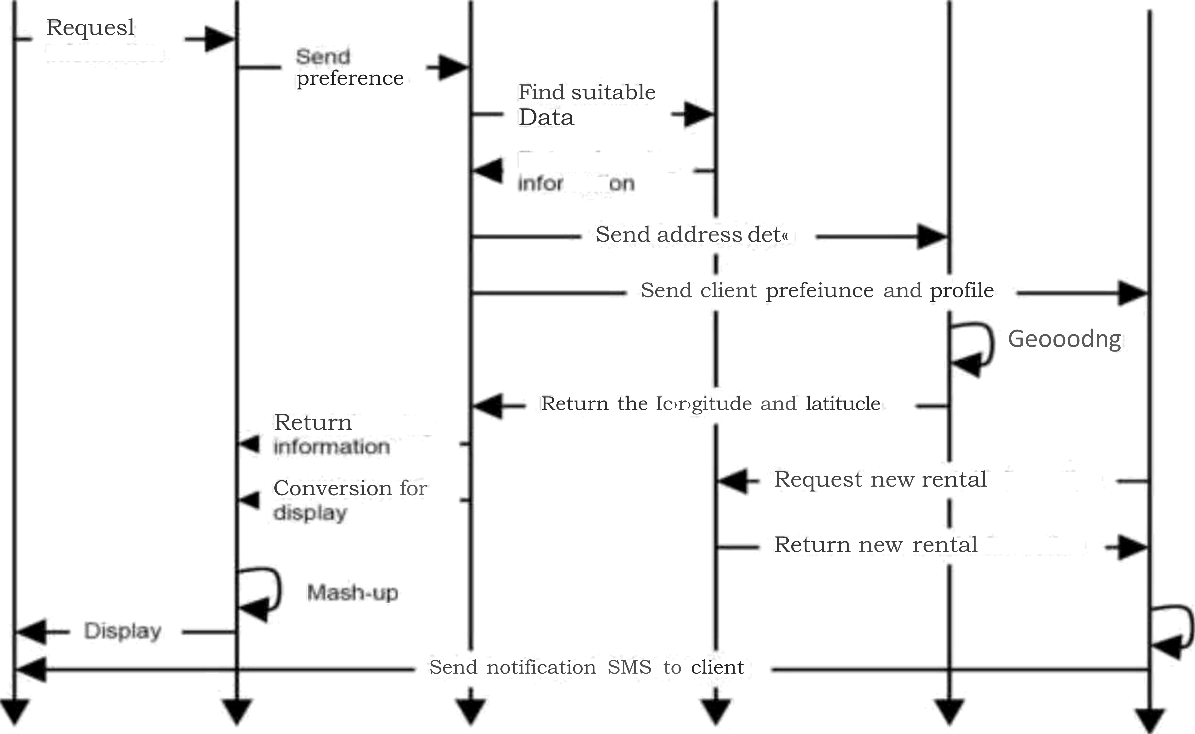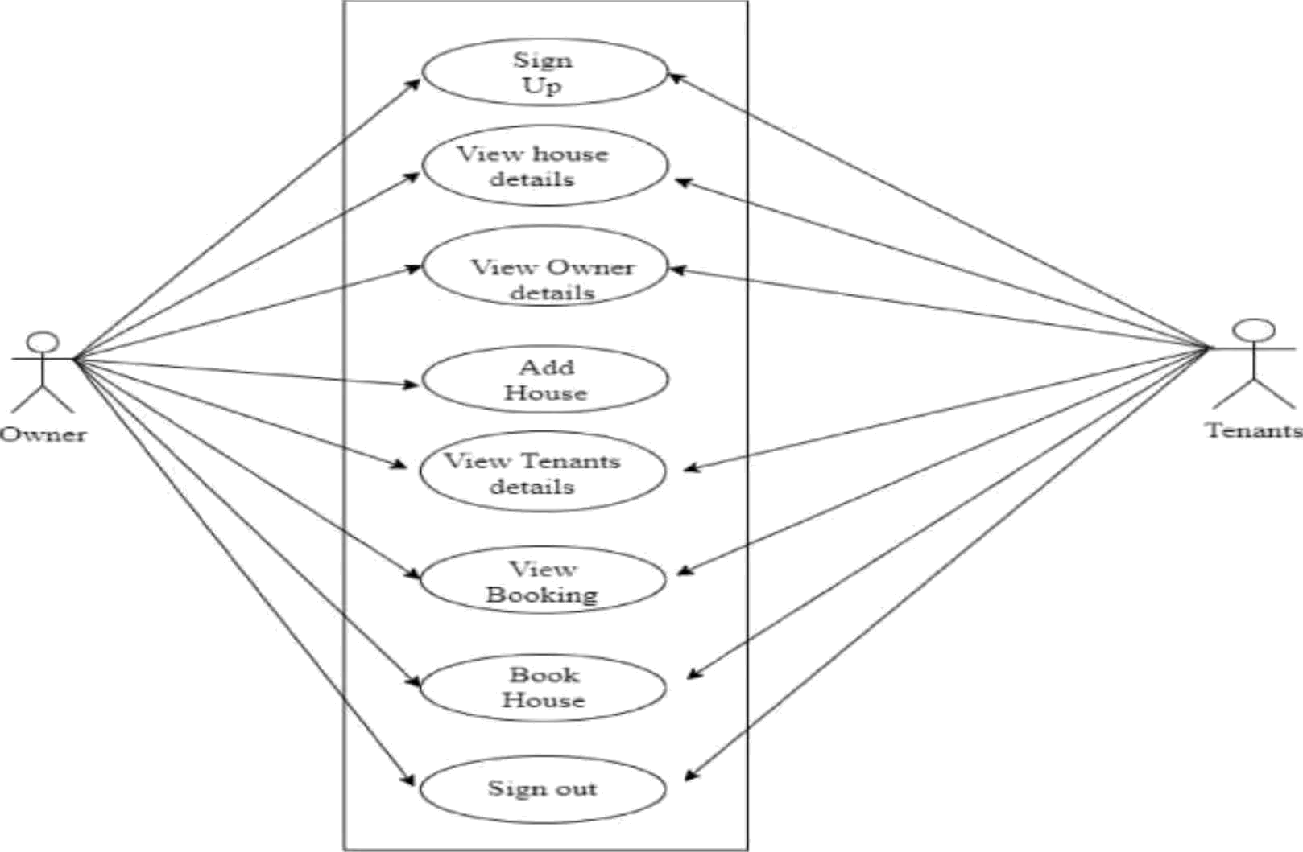

**Interior House Hunting Checklist**

The interior of your new home is where you will spend most of your time. This is where many memories will be made. Regardless of what you purchase, you will make the interior of your new home your own. It will suit your style and it will fit your personality. That’s why it’s important to start with your core Must-Haves so you can build the rest around it. Here is the list of interior items the Home Hunting Checklist will ask you to prioritize:

* **Number of Bedrooms:**You’ll need to know if everyone gets their own room, or if some members of the household will share a room. Additional things to consider for bedrooms would be do you need all the bedrooms on the same floor? Does the master bedroom need to be next to the baby’s room? Make sure your House Hunting Checklist reflects what you want and what you need.
* **Number of Bathrooms:**Do you want a master bathroom? Do you need at least one full and one half bathroom, or will one full bathroom be enough? There are 4 primary items that make up a bathroom: toilet, sink, shower and bathtub. A full bathroom has all four of these items. A half bathroom is typically a toilet and sink. How many bathrooms does your new home need?
* **Basement or Cellar:**Some people really want a basement or lower level to their home. Finished basements can be an extension of your main level living space for game rooms, kids play rooms and entertainment rooms. If it’s not finished, it can be a primary location for storage or a great place for children to burn off their energy during rainy days. Basements also serve as shelter from tornadoes.
* **Laundry**: Considerations for laundry must be taken. Do you need a washer and dryer in the home or do you use the local laundromat? Does the laundry room need easy access on the same floor as all of your primary rooms to avoid going up and down stairs? Is it too close to bedrooms causing limited working hours due to noise? These are important questions to ask yourself as you define your Must-Haves.
* **Open Floor Plan**: This is a big one for my wife. She loves her space and her ability to see what’s going on around the house. Closed off rooms in a home can feel claustrophobic or too isolating for some people. Open floor plans tend to brighten rooms due to shared light from multiple windows and offer a more free-to-move feel.
* **Main Mechanicals on the House Hunting Checklist**:
  + **HVAC** – The heater, vent system and air conditioner (HVAC) are the beating heart of the house. They keep the home’s temperature steady and comfortable during mother nature’s highs and lows. Do you require central AC or will a window unit suffice? I’m a guy who sweats every minute of his life, so a window AC unit will not cut it, but others may not mind. What type of heat do you want in your home; radiators, floor boards, or circulated air? Having these items in working order is important, and when you begin conducting your house search, be sure to note how old these items are in the house. They do not last forever and they’re not cheap to replace, so keep that in mind as your house shopping.
  + **Water Heater** – Another important work horse. Cold showers are a healthy trend these days, but most people prefer to bathe in warm water. Look at the water heater from the same perspective as the HVAC system.
  + **Water Softener** – Some homes must have one due to the hard water in the area. Not only is soft water better for bathing and the feel of your clothes, but untreated hard water can cause minerals to build up in the home’s pipes. This can cause all kinds of problems from leaks to clogged pipes. If you know the water is hard in the area, make sure the homes you look at have a working water softener. It’s also important to know if the homeowner owns their water softener or if they’re renting it, because you’ll need to decide your plan if you buy the home.
* **Fireplace**: A fireplace can be a room’s focal point or it can just sit in the corner unused collecting dust. I personally enjoy the crackle and aroma of a wood burning fireplace, but many prefer the ease of a gas fireplace. A home with a fireplace can be a decision-maker for some folks. Whether you want a fireplace or not, the home you want may come with one, so it’s important to understand they do require maintenance. So, not having a fireplace might be important to you. At a minimum, when you’re looking to purchase a home with a fireplace it’s a good idea to have it inspected. You’ll want to know if it’s in working order, clean and critter free.
* **Floors**: Hardwood or carpet? Carpeting can be replaced or installed when you move into your new home, and you can make it whatever you want. But, that takes money so you’ll need to consider the condition of the floors when you’re house searching. If you prefer hardwood floors, installing those is more costly. There are benefits to both carpet and hardwood floors when it comes to maintenance and appearance, and everyone has their preference, so it’s good to know what’s preferred up front.
* **City Water**: Do you want city water or do you prefer a well? This will depend heavily on the property’s location. More rural homes or cabins may have a private well and require additional work to maintain safe and usable water.
* **City Sewer**: Do you want city sewer lines? Again, this will depend primarily on the home or cabin’s location. Many rural homes may not be connected with city sewer lines and instead would rely on a [**septic system**](https://www.epa.gov/septic/how-your-septic-system-works) to maintain waste water.
* **Crawl Space**: Many split-level homes will have a crawl space. Crawl spaces are not a love or hate thing. Instead they are hated by 99.9 percent of the population. Why? Because they are not convenient. But, they can be tolerated by most people. They typically provide storage space and that’s welcomed, but it is not easily accessible. You’ll likely need to “crawl” under some steps and pull everything out to find the one thing you need, then put everything back. Not ideal, but can you tolerate a crawl space? That’s the question you need to answer. If not, add “no crawl space” to your Must-Haves.
* **Ceiling Fans**: Air circulation is a big deal for some people and having ceiling fans already installed is a big plus. Especially if the home you’re considering has vaulted ceilings. Installing a ceiling fan onto a vaulted ceiling is not easy. It may require a professional unless you have access to a sufficient ladder and the will to do the job. Ceiling fans probably are not a deal breaker for most home buyers, but it’s good to have the conversation about who wants them and who doesn’t.
* **Dishwasher/Garbage Disposal**: At a minimum you’ll want to agree on if these items are wanted. That way if the house you want to buy does not already have these items, you size up the cost to install them.
* **Size of the Rooms**: The size of the rooms matter. If you have a large dining room table, then a small kitchen cove will not work for you. If your 17 year old is 6’ 7” and 280 lbs, a 7’ x 10’ bedroom probably will not work. Try to establish guidelines for the size of rooms you will need to accommodate you, your family and all you plan to move into your new house. If necessary, add minimum sizes to your Must-Haves.
* **Accessibility (Easy Access)**: This gets to be more important as you age. A home is often a long-term purchase. Most people choose a 30-year mortgage. So keep in mind as time passes and the body begins to not function like it did before, these accessibility questions may become more relevant to you and your family. Depending on your circumstances, some of the items below may need to be added to your Must-Haves.